**Question-1:**

Screenshots from a sample run:

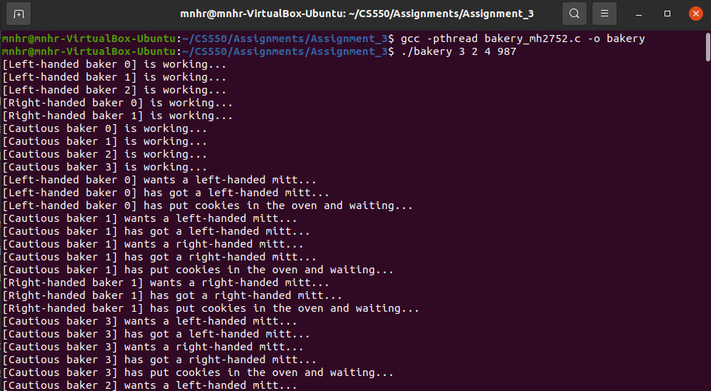

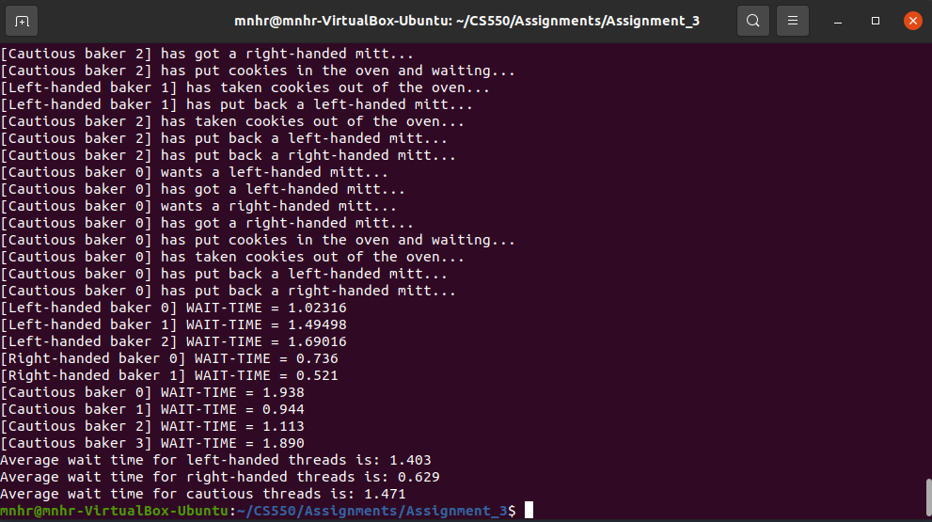

Checking with check_bakery.py:

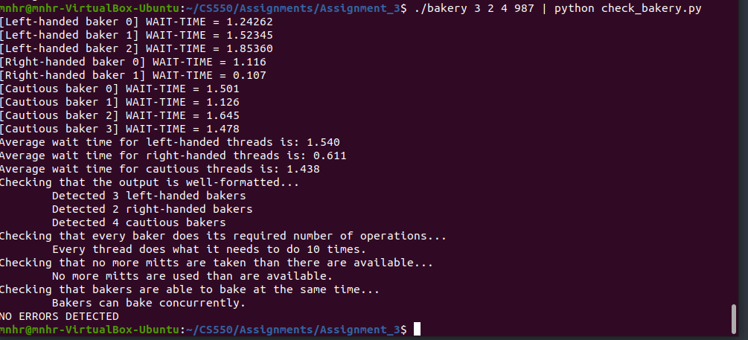

**Question-2:**

Screenshots from 3 different runs with 5, 10, and 50 of each thread types:

For N = 5:

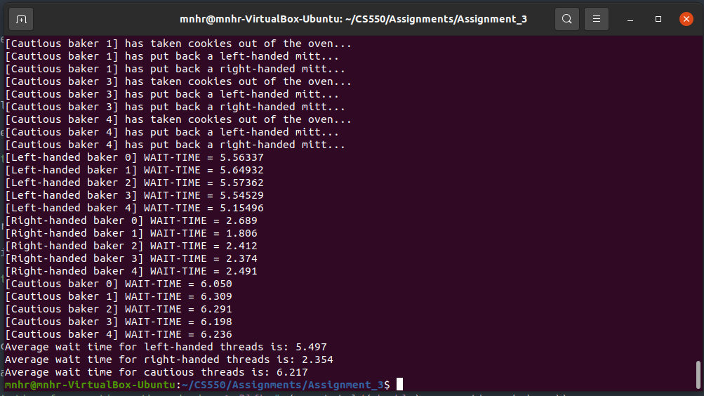

For N = 10:

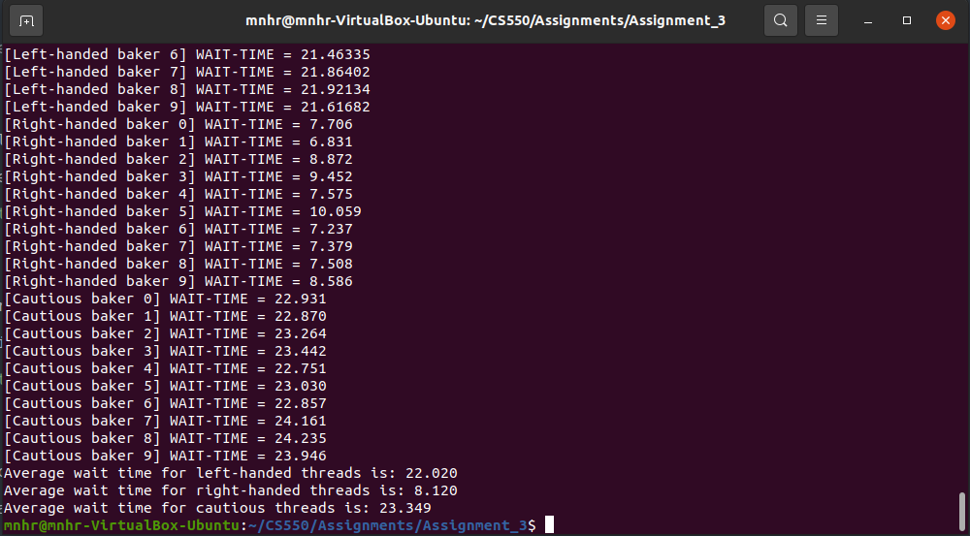

For N = 50:

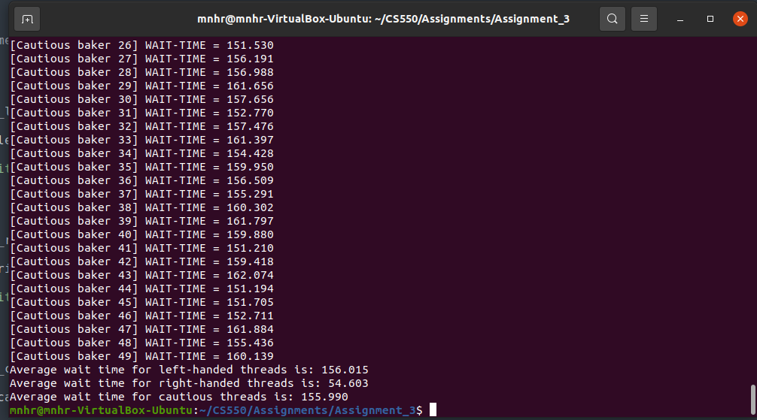

In the screenshots above, we observe the following:

| **Num of Each Thread Type** | **Left-handed threads Avg. Wait Time (seconds)** | **Right-handed threads Avg. Wait Time (seconds)** | **Cautious threads Avg. Wait Time (seconds)** |
| --- | --- | --- | --- |
| 5 | 5.497 | 2.354 | 6.217 |
| 10 | 22.020 | 8.120 | 23.349 |
| 50 | 156.015 | 54.603 | 155.990 |

From the average wait time values, it’s evident that in all three cases, right-handed threads are treated more favorably than the other two types of thread.

This happens because, when obtaining oven mitts, cautious threads obtain a left-handed mitt first and then obtain a right-handed mitt. As a result, right-handed threads implicitly get an advantage while obtaining right-handed mitt (cautious threads are waiting/obtaining left-handed mitt first). Meanwhile, left-handed threads might be waiting for left-handed mitts already held onto by cautious threads.

As a result, right-handed threads have a lower average waiting time than left and cautious threads.